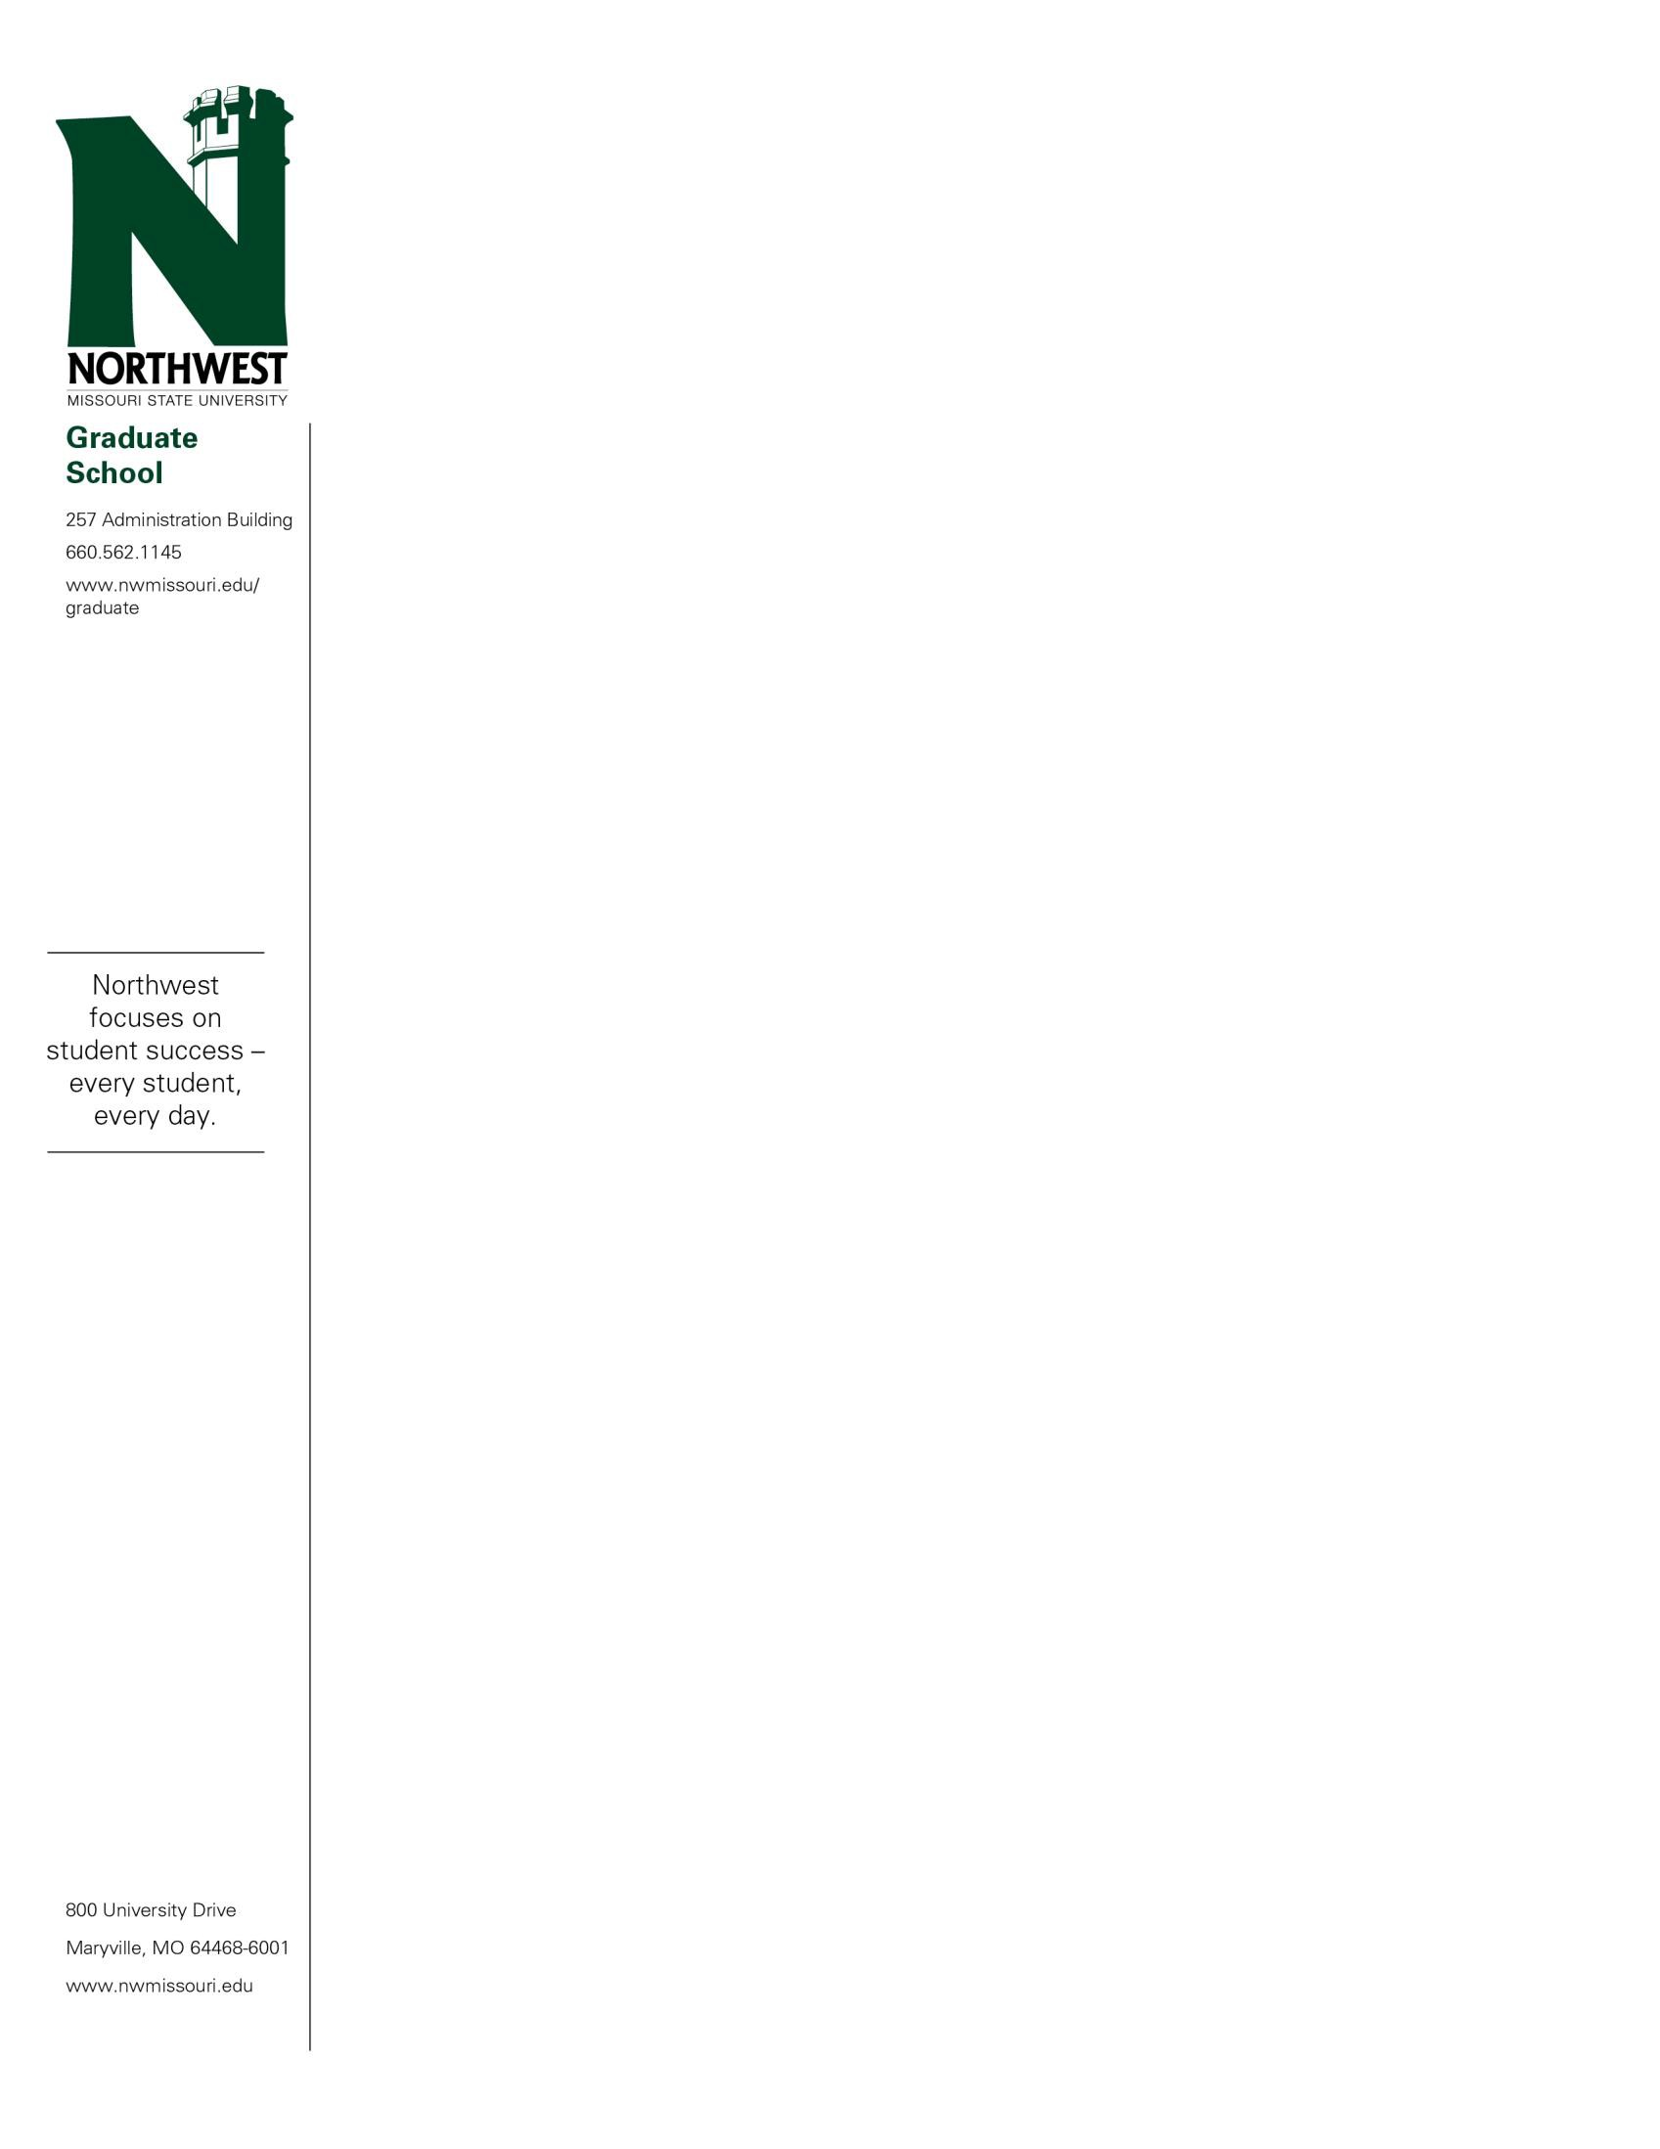

June 8, 2022

«FIRSTNAME» «LASTNAME»

«STREET»

«CITY», «STATE» «ZIP»

Dear «FIRSTNAME»:

Congratulations! You have been admitted into the Northwest Missouri State University Online Professional Master of Science: Data Analytics program beginning in the «TERM» semester.

«ADVISOR» serves as your academic advisor for the program. Her email is «ADVISOREMAIL».

Please review this letter carefully and contact the Graduate Office at 660- 562-1144 with any questions or concerns.

All coursework submitted to fulfill a master’s degree must be completed within an eight-year time period.

Northwest Missouri State University is proud of a long tradition of academic excellence, a fine faculty and a strong academic curriculum. We are happy for the opportunity to help you meet your educational goals.

Sincerely,

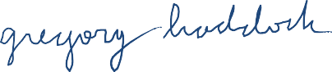

Gregory Haddock

Associate Provost of Graduate and Professional Studies